**Semi-Annual Narrative Report (SNR)**

# **1. Project Details**

GUIDELINES: Please complete the following table with details of the project.

|  |  |
| --- | --- |
| Project Number | <4081-MYP > |
| Project Title | < Grarbet Tehadiso Mahber Comprehensive Medical and Rehabilitation Project> |
| City/ Country/ Region | < Butajira, SNNPR, Ethiopia> |
|  |  |
| Name of Contractual Partner | < Grarbet Tehadiso Mahber > |
| Other Implementing Partners | < None > |
|  |  |
|  |  |
| Duration of Project | <3 Years > |
| Project Start Date | <01/01/2021> |
| Project End Date | <31/12/2023> |
| Project Cycle | < January - December > |
|  |  |
| Report Submitted by; |  |
| Name | < Mr. Teshome Tulu, Mr. Desalegn Amanuel, Prof. Redda TekleHaimanot > |
| Designation | < Deputy Executive Director, Program Officer, Executive Director > |
| Email Address | < gblgtm@yahoo.com > |
| Date of Submission | <15/07/2020> |

# **2. Summary of Results Achievements**

*GUIDELINES: Insert a qualitative ‘summary’ of the overall progress of the project towards its Result areas. Please focus on the changes (intentional or unintentional) that have come about as a result of implementation of activities. Limit your response to 1 paragraph per result area.*

**Result 1: - Quality eye care service provided**

Grarbet Tehadiso Mahber (GTM), with support from CBM, offered a comprehensive and inclusive eye care service through its base facilities in Butajira and Batu. In the project's intervention districts ;in the SNNP and Oromia regions, beneficiaries were screened and treated for the main causes of preventable blindnessnsuch as Trachoma, Cataract, and Uncorrected Refractive Error (URE) during the period January to June, 2021. In addition, in close cooperation with CBM-CO, quality assurance procedures for cataract surgery were implemented to assure a positive outcome of the intervention.

**Result 2: -Essential ENT services provided to rural people in central Ethiopia**

GTM offered critical ENT services in rural central Ethiopia, focusing on ear and hearing care. Currently, government primary health care facilities in rural areas did not provide basic ear and hearing treatment. Patients who needed sophisticated surgical operations were also treated at surgical camps organized by GTM in partnership with CBM’s consultant Dr. Uta Froeschl and the St. Paul's Hospital Millennium Medical College (SPHMMC).

**Result 3. Persons with disability screened**

One of the project's main objectives was to provide physical rehabilitation services to those who have disabilities. GTM's base facility in Butajira offers physical rehabilitation services such as physiotherapy, as well as the production and distribution of assistive devices for people with disabilities. In addition, GTM continued providing maintenance of assistive devices for people with disabilities through its workshop. This gave persons with disability the chance to become self-supporting and productive.

**Result 4. Medical services provided to patients with Epilepsy in rural central Ethiopia**

People with epilepsy were being screened, treated, and followed up as part of GTM's comprehensive medical and rehabilitation care for the rural community in central Ethiopia. GTM runs an Epilepsy Clinic in Butajira, which has been staffed by a qualified Health Officer and nurse. On situations requiring advanced management, the Health Officer consulted the neurologist (Prof. Redda).

# **3. Narrative Reporting on Activity Implementation**

*3.1 GUIDELINES: Which activities were planned to be implemented in the first six months (Q1 and Q2)? Please list down the Activity Name and Number only.*

**List of activities planned to be implemented for the reporting period**

**Result 01: Quality eye care service provided**

* 1. Ophthalmic nurses and their helpers, under the supervision of the ophthalmologist, will systematically screen patients, perform eye examination and treat eye diseases
  2. Surgery for in-grown eye lashes (Tarsatomy)
  3. Purchase of medicines and medical supplies for Cataract surgery at Butajira and Batu eye care center
  4. Screening for refraction errors
  5. Eye glasses production and distribution to the population of the project districts

1.7 Safeguarding training for project staff

1.8 Sign language training for selected project staff

**Result 02: Essential ENT services provided to rural people in central Ethiopia**

* 1. Screening and treatment of patients for ENT problems
  2. Treatment of Patients treated for ear infection
  3. Removal of foreign body for adults and children
  4. Audiometry for persons with Hard of Hearing
  5. ENT surgeries performed

**Result 03: Person with disability screened**

* 1. Screening of person with disability
  2. Orthopedic Surgery

**Result 04: Medical services provided to patients with Epilepsy in rural central Ethiopia**

4.1 Newly enrolled patients with Epilepsy treated

4.2 Patients with Epilepsy will be followed

*3.2 GUIDELINES: Using the list above, please report on the activities implemented during the last 6 months. Describe if any targets were achieved, or explain any variance in achieved versus planned activities in the reporting period. Explain who the main beneficiaries/ participants were.*

**Performance of activities Implemented during the reporting period**

**Result 01: Quality eye care service provided**

* 1. **Ophthalmic nurses and their helpers, under the supervision of the ophthalmologist, will systematically screen patients, perform eye examination and treat eye diseases**

During the reporting six months, 32,153 adults (Male: 17,093 and Female: 15,060) and 7,415 children (Boys: 3,850 and Girls: 3,565) were screened and treated for eye diseases. Special emphasis was given to the leading causes of avoidable blindness namely, Trachoma, Cataract and Uncorrected Refractive Error (URE). Patients were screened and treated using the two GTM base centers in Butajira and Bate/Zeway. Among patients screened for eye problems, a total of 3,038 adults (Male: 1,674 and Female: 1,364) and 867 children (Boys: 489 and Girls: 378) were diagnosed as having active trachoma and were treated with TTC eye ointment.

GTM has extended its services to Dilla, an administrative town of Gedio Zone, SNNPR and Kofele town, south of Batu/Zeway to screen patients for eye diseases. The outreach programs were organized in collaboration with The Three Aid Foundation (TTAF), a longtime partner of GTM. A total of 2,379 patients were screened. Out of which screened 17 with trachoma complication (Trachoma Trichiasis: TT) were operated, 420 patients were identified as having cataract. The patients diagnosed to have cataract were referred to GTM specialty eye care center in Batu and operated accordingly.

GTM has also launched a project entitled,” GTM comprehensive and inclusive eye care service Outreach Eye Care Project in SNNPR, Ethiopia “with support from Netherlands based SeeYou Foundation in four districts. During the reporting period, a total of 1,299 patients have been screened and treated for different eye diseases.

* 1. **Surgery for in-grown eye lashes (Tarsatomy)**

Patients with Trachomatous Trichiasis were also operated during the reporting period. A total of 436 lid surgeries were performed on 296 adults (Male: 89 and Female: 207) and 2 children (Boy: 1 and Girl: 1). The number of TT surgeries performed by GTM has shown a significant increase during the reporting six months as compared to the same period of the previous year. This is due to the fact that GTM has reactivated its outreach eye care program which was scaled back after the completion of the two major CBM supported Trachoma projects in mid-2019.

* 1. **Purchase of medicines and medical supplies for Cataract surgery at Butajira and Batu eye care center**

GTM's two specialized eye care centers in Butajira and Batu perform cataract surgery pm rural patients in central Ethiopia. During the reporting period a total of 2,045 adults (Male: 1,026 and Female: 1,019) and 11 children (Boys: 9 and Girls: 2) were operated for cataract. Emphasis was given on the preparation and satisfactory outcome of patients operated for cataract. The majority of the GTM beneficiaries were from remote rural villages. As a result, patients were admitted to the hospital for three days to be monitored before, during and after operation. This ensured a positive surgical outcome. Furthermore, GTM and GMF Australia initiated the '[Vision 2021](https://click.mlsend.com/link/c/YT0xNzI0MzYyMzc1ODY1MzA5NDEzJmM9ejh2NyZlPTAmYj02NDg3NTk1NjImZD1wN3g3bjRm.foJcMtEzy3hr7y0YjuTJmtlV_vUQk4oEkwfJkcPYiS4)' program to provide mainly cataract surgeries in rural Central Ethiopia. A total of 200 cataract patients benefited from the service sponsored by GMF Australia.

GTM has been also active in academic training of ophthalmologists in Ethiopia, in addition to providing the routine services. Residents in ophthalmology from St. Paul's Hospital Millennium Medical College (SPHMMC), (one of the country's largest medical schools), get attached for 6 weeks at the GTM center Butajira for practical training. During the reported period a total of 7 residents (Males:5 and Females:2) attended the on-the-job training.

* 1. **Screening for refraction errors**

One of the flagship eye care initiatives of GTM was its optometry service. Using its two specialized eye care centers, GTM screened a total 5,891 adults (Male: 3,880 and Female: 2,011) and 246 children (Boys: 116 and Girls: 130) for refractive errors during the reporting period.

* 1. **Eye glasses production and distribution to the population of the project districts**

Beneficiaries who required spectacles were given low-cost eyeglasses. The spectacles were produced and fitted at GTM's optical workshops in Butajira and Bate/Zipway. Using its two workshops, GTM produced and distributed eye glasses for a total 3,723 adults (Male: 2,669and Female: 1,054) and 111 children (Boys: 40 and Girls: 71) for correction of refractive errors during the reporting period. GTM, in collaboration with Essilor, a French based Optical Company, has provided free eye screening and eye glasses for persons with disability and relatives in their villages. A total of 1,000 eye glasses were distributed to PWDs and their relatives.

**1.7 Safeguarding training for project staff**

GTM is committed to doing everything within its power to avoid unintended harm or accidents to children and adults at risk during its operation. In this regard, it was important for staff working with children and adults at risk to ensure that they were aware of the responsibilities placed on them. Hence, GTM provided safeguarding awareness training for 22 staff of GTM Bate (Male:13, Female: -9) who have had direct contact with the patients. The aim of the training was to create safe and suitable environment for children and adults at risk. At the end of the training, the participants selected safeguarding committee members and focal person. This committee received incidents of abuse, conduct investigation and made recommendation to the management body for further corrective actions.

**1.8 Sign language training for selected project staff**

GTM strives to bring an improved quality of life for the poor community through the provision of comprehensive eye care, ENT, epilepsy and other essential health services in accessible, affordable, sustainable inclusive and environmentally friendly manner. In order to achieve the mission of GTM, inclusion of persons with hard of hearing while delivering the service was found crucial. In this regard, GTM rendered training on basics of Sign Language for 9 staff (Male:5, Female:4). The aim of the training was to provide basic sign language for GTM’s Staff communicated with beneficiaries with hard of hearing. The training was given by professional trained in special needs education and inclusion.

**Result 02: Essential ENT services provided to rural people in central Ethiopia**

* 1. **Screening and treatment of patients for ENT problems**

GTM provided advanced ENT care for the community in its operational and adjacent districts through its walk-in clinic at Butajira and using routine surgical camps organized in close collaboration with Dr. Uta Froeschl of SPHMMC. During the reporting period, a total of 5,472 adults (Male: 2,870 and Female: 2,602) and 2,049 children (Male: 1,047 and Female: 1,002) were screened and treated for ENT problems.

* 1. **Treatment of Patients treated for ear infection**

Ear infection is one of the main causes of hearing loss. Among the total patients screened, 1,434 adults (Male: 744 and Female: 690) and 1,224 children (Boys: 653 and Girls: 571) were treated for ear infections at the center.

* 1. **Removal of foreign body for adults and children**

One of the common procedures in ENT department has been the removal foreign bodies in ear and nose. During the reporting six months, foreign body removals were performed for 40 adults (Male: 14 and Female: 26) and 48 children (Boys: 23 and Girls: 25).

* 1. **Audiometry for persons with Hard of Hearing**

GTM renders audiometry for patients presenting to its center with hard of hearing and recurrent ear infections. During the reporting six months, audiometry was done for 327 adults (Male: 161 and Female: 166) and 39 children (Boys: 14 and Girls: 25). The audiometry results were closely followed by Dr. Uta Froeschl.

**2.5. ENT surgeries performed**

GTM resumed its ENT surgical camp in partnership with Dr. Uta Froeschl as part of the collaboration between GTM, SPHMMC and CBM. During the reporting period two surgical camps were organized. A total 39 adults (Male: 22 and Female: 17) and 12 children (Male: 5 and Female: 7) were operated for major surgical ear problems. ENT residents from SPHMMC also joined the surgical team for hands-on training. Feedback from the residents has been very positive. COVID-19 safety is still our priority in GTM facilities as it has been throughout the pandemic. Hence, COVID-19 results were obtained for all patients prior to the screening and surgery in addition to the routine COVID-19 safety protocol.

**Result 03: Person with disability screened**

* 1. **Screening of person with disability**

Provision of physical rehabilitation services for persons with disability is one of the main activities of the project. Using GTM's base center in Butajira, a total of 966 adults (Male: 480, Female: 486) and 321 children (Male: 271, Female: 150) were screened for physical disability. GTM physiotherapist and his assistant provided physiotherapy services for 1,028 new clients and 1,112 clients on active follow up.

GTM provides management of Clubfoot to beneficiaries from the rural villages using the Ponseti technique as part of its physical rehabilitation program. During the reporting period, the rehabilitation team applied PoP for 240 clients needing the service. The service was closely supported by Hope Walks and TTAF.

Assistive devices for mobility such as, crutches, braces, orthopedic shoes, Ankle-foot orthoses (AFO) and Knee-Ankle-Foot orthoses (KAFO) were produced inside GTM orthopedic workshop for persons with physical disability. This will enable persons with physical disability to become self-sufficient. During the reporting period, appliances and locomotive devices were distributed for 385 adults (Male: 281, Female: 104) and 87 children (Male: 54, Female: 33). Moreover, appliances were maintained for a total of 109 adults (Male: 54, Female: 55) and 128 children (Male: 48, Female: 80). Unavailability of Polypropylene, a raw material used for the production of braces and orthoses has seriously impacted the production of mobility appliances. In this regard, GTM approached Arbaminch Physical Rehabilitation Center, which generously provided GTM polypropylene adequate for one year.

* 1. **Orthopedic Surgery**

GTM provided corrective surgical treatment and rehabilitation to 28 beneficiaries (Boys:19 and Girls:9) during the year. These were mainly children with clubfoot. The surgery was performed by GTM Orthopedic Surgeon, Dr. Getahun Yetbarek.

**Result 04: Medical services provided to patients with Epilepsy in rural central Ethiopia**

**4.1 Newly enrolled patients with Epilepsy treated**

Care and treatment for persons with epilepsy was also one of GTM's central activities during the reporting period. A total of 146 children (Male: 77 and Female: 69) and 164 adults (Male: 87 and Female: 77) were newly enrolled to the epilepsy clinic.

**4.2 Patients with Epilepsy will be followed**

A total of 1,207 children (Male: 551 and Female: 656) and 1,468 adults (Male: 662 and Female: 806) visited the epilepsy clinic for an active follow up. The seasonal availability and high price of drugs for the treatment of epilepsy remained a key concern.

# **4. Challenges and Lessons Learned**

*GUIDELINES: Please complete the table below with challenges that were encountered during the reporting period and the lessons learned. Include any solution that you plan to implement in the next reporting period. (If you have used the Status Column in the Indicator Tracking Sheet (Column K) to report Challenges against specific indicators, make sure you elaborate on the challenge in the table below)*

|  |  |
| --- | --- |
| Challenge | Lessons learned / solutions |
| <scale down of outreach eye care service > | < After the completion of CBM sponsored two Trachoma Control projects, GTM eye care service has been limited to GTM Centres in Butajira, and Batu in Zeway. After knocking different doors to activate the outreach eye care service, GTM has finally found the Dutch organization, SeeYou Foundation, which was willing to financially fund the GTM comprehensive and inclusive eye care service. The project was being implemented in four rural intervention districts of the SNNP Region through an outreach eye care service. > |
| < Unavailability of polypropylene, a raw material, for the production of braces for persons with disability> | < This has been a major hindrance to the production of mobility appliances during the previous two years. In order to solve this problem, GTM approached Arbaminch Physical Rehabilitation centre. They generously provided GTM Twenty polypropylene sheets and sixty aluminium bars. > |
|  |  |

# **5. Changes in Implementation Plan and Personnel (if applicable)**

*GUIDELINES: Please use the space below to specify any changes to (I) the implementation plan (strategies, timelines, targets or key results; also specify if any approval for changes has been sought from CBM), (II) any changes in personnel at the organization’s senior management level, (III) key positions related to the project implementation.*

No reportable programmatic revision is sought during the reporting period.

**6. Risk Update (If applicable)**

*GUIDELINES: Have any of the risks identified during the project design materialized or changed?*

The emergence of COVID-19 pandemic is still the risk for the project as it incurred extra cost for the project and also discourage patients from attending the clinic.

**7. Activity Forecast**

*GUIDELINES: Which activities are planned to be implemented in the next 6 months (Q3 and Q4)? Please list down the Activity Name and Number only.*

**List of activities planned to be implemented in the next six months**

**Result 01: Quality eye care service provided**

* 1. Ophthalmic nurses and their helpers, under the supervision of the ophthalmologist, will systematically screen patients, perform eye examination and treat eye diseases
  2. Surgery for in-grown eye lashes (Tarsatomy)
  3. Purchase of medicines and medical supplies for Cataract surgery at Butajira and Batu eye care center
  4. Screening for refraction errors
  5. Eye glasses production and distribution to the population of the project districts

1.7 Safeguarding training for project staff

1.8 Sign language training for selected project staff

**Result 02: Essential ENT services provided to rural people in central Ethiopia**

* 1. Screening and treatment of patients for ENT problems
  2. Treatment of Patients treated for ear infection
  3. Removal of foreign body for adults and children
  4. Audiometry for persons with Hard of Hearing
  5. ENT surgeries performed

**Result 03: Essential ENT services provided to rural people in central Ethiopia**

* 1. Screening and treating of patients for ENT problems
  2. Treatment of patients for ear infection
  3. Appliances and devices produced and distributed
  4. Removal of foreign body for adult and children patients
  5. Orthopedic surgeries performed

**Result 04: Person with disability screened**

4.1 Newly enrolled patients with Epilepsy treated

4.2 Patients with Epilepsy will be followed

# **8. Photos**

*GUIDELINES: Please use the space below to paste any photos, with captions, news items etc. related to the project. Please ensure that written consent has been obtained from all identifiable people in the photos.*

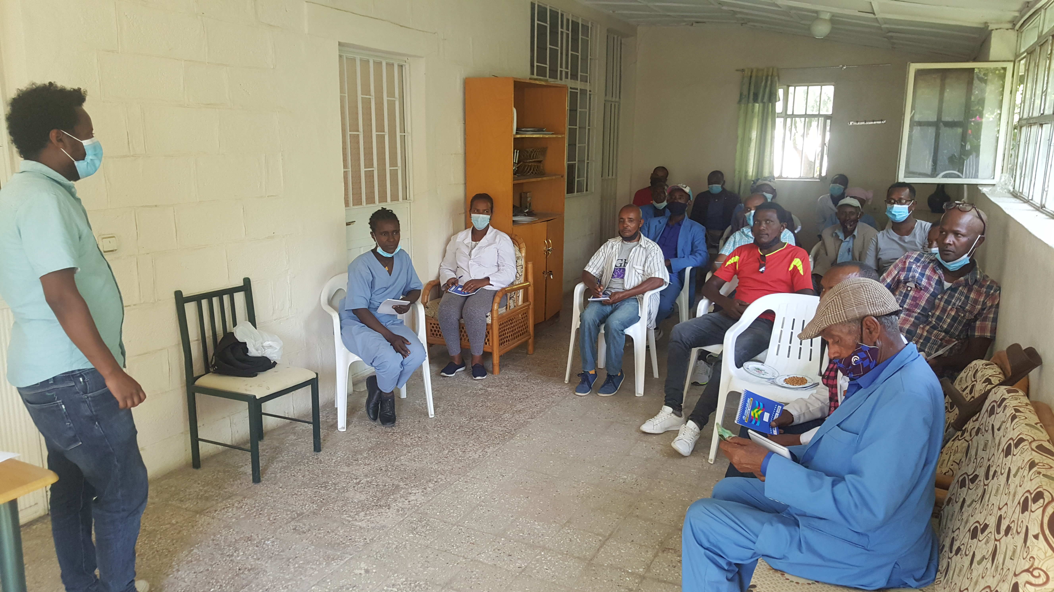

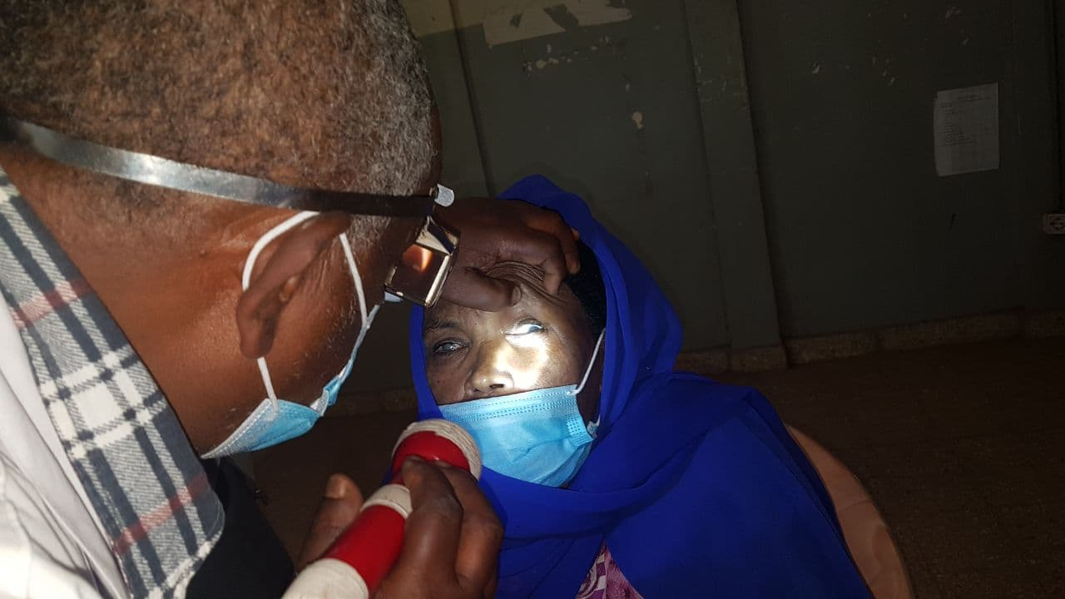Figure 1: - GTM staff attending a Safeguarding Training Event

Figure 2: -The ophthalmic nurse while examining a patient at the outreach clinic

# **9. Comments from CBM Country Office[1]**

*GUIDELINES:* ***(Only to be filled by the Country Office)*** *Please use the space below to briefly comment on the quality of project implementation and reporting, and describe whether the project is on track and on schedule. If a monitoring visit was conducted during the last 6 months, what were the main findings and recommendations?*

GTM is one of the most respected health facilities by the communities in the area which made it preferable among others by a large number of rural and urban people both in and outside the project catchment areas. It has shown the competence to efficiently and effectively manage CBM funded projects over the last many years. Using the generic scale to evaluate the success of the project which is accomplishing the project plan as per budget, schedule and scope and quality, and including CBM’s compliance requirements, GTM, in its performance and achievement in the midterm reporting period in this particular project has been very good. It has achieved to accomplish almost all the planned activities under each result area. By so doing, it has contributed a lot in altering the quality lives of many underserved populations including children, men and women in eye health, EHC, Physical rehabilitation and epilepsy. As it has always been doing, GTM was able to utilize all of the allotted budget for the Q.1 and Q.2 which reached 100%, and in very good status in utilization against the annual budget and carry over. The previous identified gaps that needed improvement in regards to financial management; where the partner showing failure sticking to the financial principles or rule that it would not have to rotate budget from one to another has now been improved.

In terms of compliance, the programme Officer and the Executive director have been so responsive and co-operative to various project related communications from CBM, CO via email, telephone. They both have been able to timely deliver finance and programme reports with good quality. The partner was also reactive to CBM capacity building activities in areas of safeguarding, gender requirements.

Therefore, with continued follow up and support of the project implementation, GTM would keep on showing significant achievement in meeting the project objectives which would benefit a number of poorest beneficiaries which complements the effort of the government which is meant to access healthcare to rural people even during the next two quarters period (Q.3 & Q.4).

1. If there is no Country Office, then the Regional Office/IAA/TU is invited to share their comments as per the arrangement regarding the supervision of the project.